

THE SUPERIOR UNIVERSITY
Assignment 2

Name: SYED MUHAMMAD FAHAD
Roll No: SU92-BSSEM-S24-036
Section: BSSE 6A

Subject: Software Construction and Development
Submitted To: Sir Muhammad Qasim

Online Shopping and
Payment Processing System

class Product:
def __init__(self, item_id, item_name, base_price):
self.item_id = item_id
self.item_name = item_name
self.base_price = base_price

def calculate_price(self):
return self.base_price

def get_info(self):
return "{} -> PKR {}".format(self.item_name, self.calculate_price())

class PhysicalProduct(Product):
def __init__(self, item_id, item_name, base_price, shipping_fee):
super().__init__(item_id, item_name, base_price)
self.shipping_fee = shipping_fee

def calculate_price(self):
return self.base_price + self.shipping_fee

def get_info(self):
return "{} (Physical) -> PKR {}".format(
self.item_name, self.calculate_price()
)

class DigitalProduct(Product):
def __init__(self, item_id, item_name, base_price, discount):
super().__init__(item_id, item_name, base_price)
self.discount = discount

def calculate_price(self):
discount_amount = self.base_price * (self.discount / 100)
return int(self.base_price - discount_amount)

def get_info(self):
return "{} (Digital, {}% OFF) -> PKR {}".format(
self.item_name, self.discount, self.calculate_price()
)

class CardPayment:
def __init__(self, card_num, owner_name):
self.card_num = card_num
self.owner_name = owner_name

def pay_bill(self, total_amount):
bank_fee = int(total_amount * 0.02)
final_bill = int(total_amount + bank_fee)
hidden_card = "****-****-****-{}".format(self.card_num[-4:])

print("\n----Card Payment Processing----")
print("Card Holder : {}".format(self.owner_name))
print("Card Number : {}".format(hidden_card))
print("Subtotal : PKR {}".format(int(total_amount)))
print("Card Fee 2% : PKR {}".format(bank_fee))
print("Total Paid : PKR {}".format(final_bill))
print("Status : Payment Successful!")
return True

class CashOnDelivery:
def __init__(self, address):
self.address = address

def pay_bill(self, total_amount):
cod_charge = 150
final_bill = int(total_amount + cod_charge)

print("\n----Cash on Delivery----")
print("Address : {}".format(self.address))
print("Subtotal : PKR {}".format(int(total_amount)))
print("COD Charge : PKR {}".format(cod_charge))
print("Collect Cash: PKR {}".format(final_bill))
print("Status : Order Placed (Pending Cash Collection)")
return True

class Order:
def __init__(self, order_no):
self.order_no = order_no
self.items_list = []

def add_item(self, item):
self.items_list.append(item)
print("Success: '{}' added to cart.".format(item.item_name))

def get_total_price(self):
bill = 0
for item in self.items_list:
bill += item.calculate_price()
return int(bill)

def print_bill(self):
print("\n------------------------------------")
print(" CART SUMMARY (Order #{})".format(self.order_no))
if not self.items_list:
print("Cart is empty.")
return
count = 1
for item in self.items_list:
print("{}. {}".format(count, item.get_info()))
count = count + 1

print("------------------------------------------")
print("Subtotal Amount: PKR {}".format(self.get_total_price()))

def checkout(self, payment_option):
self.print_bill()
bill_amount = self.get_total_price()

if bill_amount > 0:
payment_option.pay_bill(bill_amount)
print("\nCheckout Completed Successfully!\n")
else:
print("\nCheckout Failed: Cart is empty.")

catalog = {
"1": PhysicalProduct("P101", "Keyboard", 2500, 200),
"2": DigitalProduct("D101", "E-Book", 1200, 10),
"3": PhysicalProduct("P102", "Book", 800, 150),
"4": DigitalProduct("D102", "Online Course", 3000, 15),
}

user_order = Order("1001")

while True:
print("\n-------------------------------------------")
print("--------ONLINE SHOPPING SYSTEM-------")
print("-------------------------------------------")
print("1. View Store Products")
print("2. Add Product to Cart")
print("3. View Cart Summary")
print("4. Proceed to Checkout")
print("5. Exit")

choice = input("\nEnter choice (1 to 5): ").strip()

if choice == "1":
print("\n----AVAILABLE PRODUCTS----")
for product_id in catalog:
print("{}. {}".format(product_id, catalog[product_id].get_info()))

elif choice == "2":
print("\n--- SELECT PRODUCT TO ADD ---")
for product_id in catalog:
print("{}. {}".format(product_id, catalog[product_id].item_name))

num = input("\nEnter product number (1-4): ").strip()
if num in catalog:
user_order.add_item(catalog[num])
else:
print("Invalid choice.")

elif choice == "3":
user_order.print_bill()

elif choice == "4":
if not user_order.items_list:
print("\nCart is empty! Add products first.")
continue

print("\n--- PAYMENT METHOD ---")
print("1. Card Payment")
print("2. Cash on Delivery")

pay_choice = input("Select payment method (1-2): ").strip()
if pay_choice == "1":
name = input("Enter Card Holder Name: ").strip()
card_num = input("Enter 16-Digit Card Number: ").strip()
payment = CardPayment(card_num, name)
user_order.checkout(payment)
break

elif pay_choice == "2":
address = input("Enter Delivery Address: ").strip()
payment = CashOnDelivery(address)
user_order.checkout(payment)
break
else:
print("Invalid payment choice.")

elif choice == "5":
print("\nExiting system.")
break
else:
print("Invalid choice, enter a number from 1 to 5.")

Output
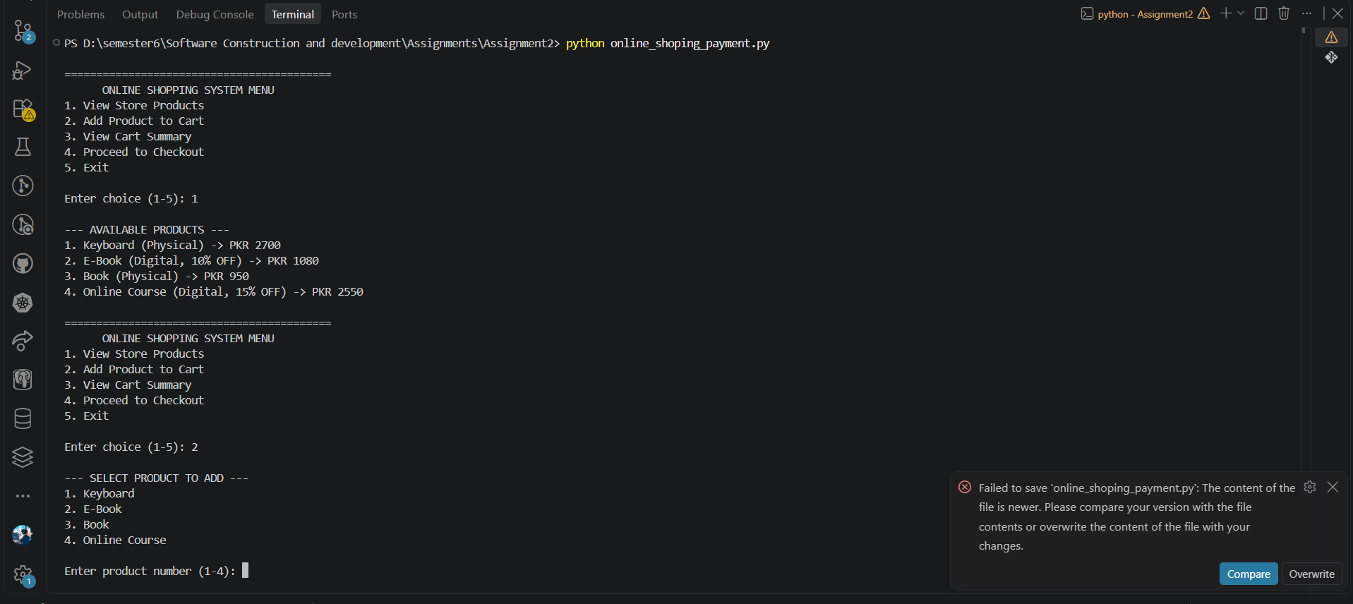
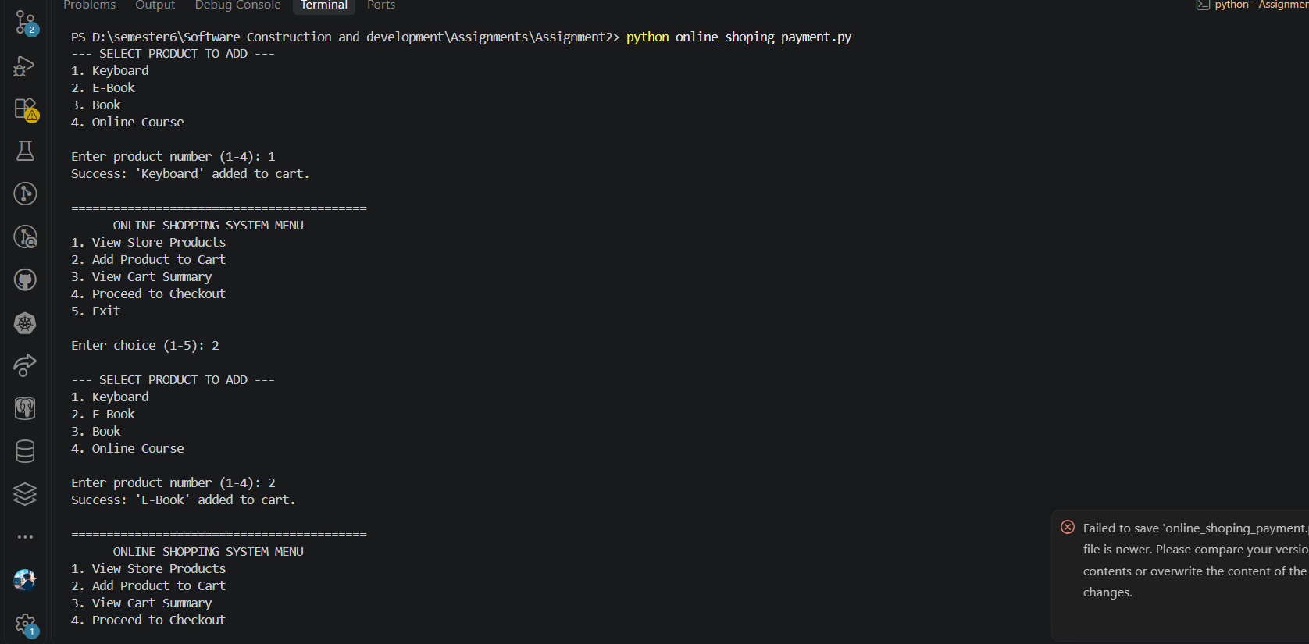
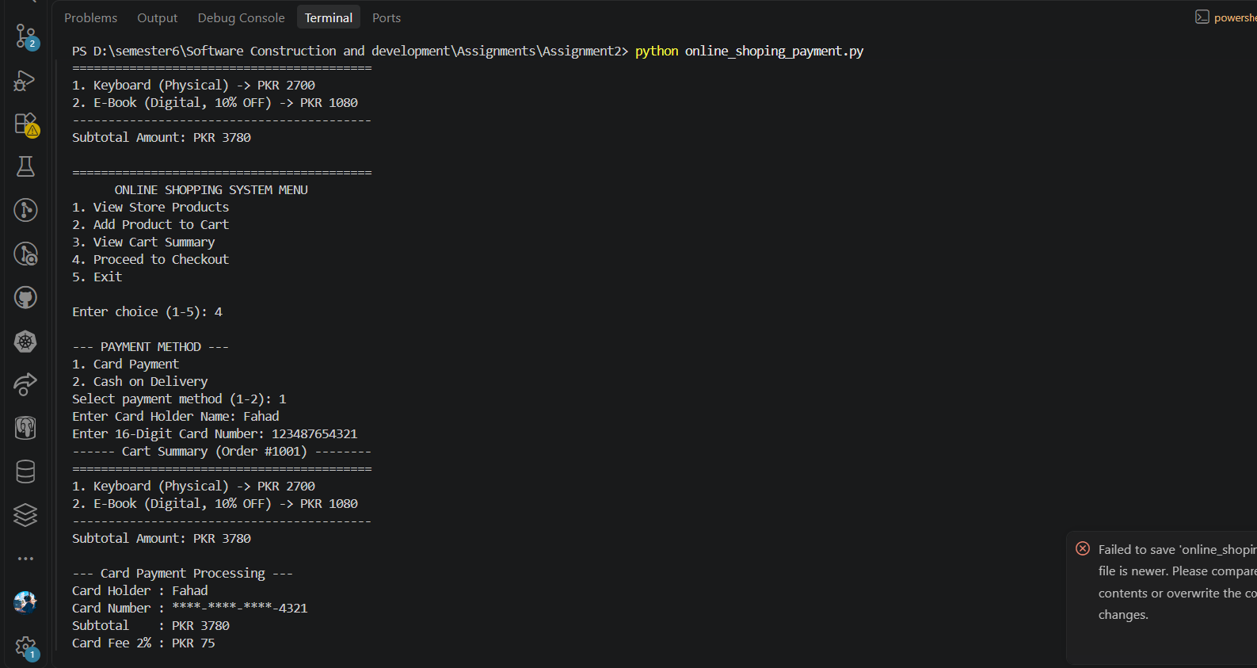
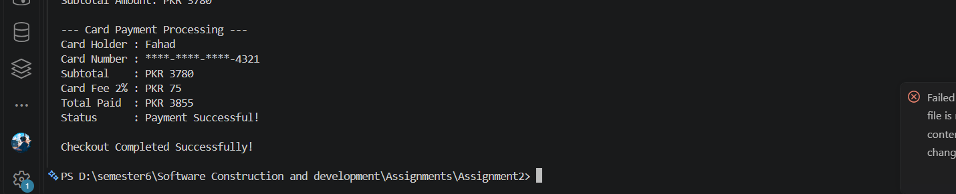
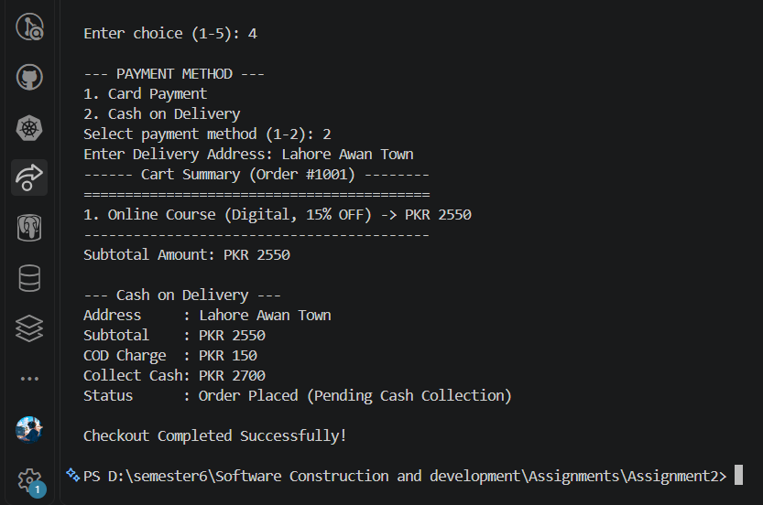
Design Diagram
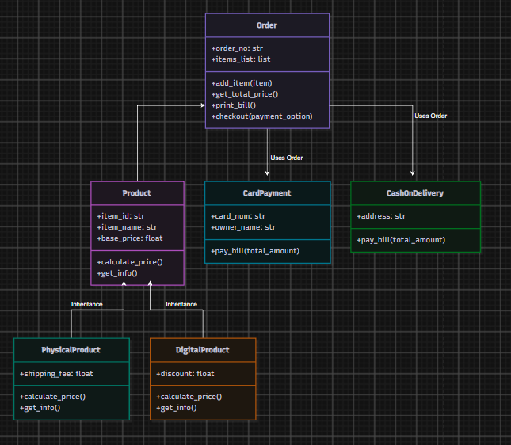

Design Explanation Report

1. Overview
For this assignment, I built a simple online shopping and payment system in Python using Object-Oriented Programming (OOP). Instead of writing everything as a single long script with loose functions and dictionaries, I used OOP to keep the code neat, readable, and easy to maintain. This approach also makes it super easy to add new products or payment options in the future without messing up the existing code.

2. Core OOP Concepts Used

A. Inheritance
- Where I used it: PhysicalProduct and DigitalProduct both extend the main Product class.
- Why I used it: All products share common attributes like item_id, item_name, and base_price. Putting these inside a parent class saved me from repeating the same setup code inside every product's constructor.

B. Polymorphism
- Where I used it:
  - Price Calculation (calculate_price): PhysicalProduct adds a flat delivery fee to the base price, while DigitalProduct subtracts a discount percentage.
  - Payment Processing (pay_bill): CardPayment adds a 2% bank processing fee, while CashOnDelivery adds a fixed delivery charge.
- Why I used it: Polymorphism lets us reuse the same function names (calculate_price and pay_bill) across different classes. Because of this, the Order class can calculate the total bill and process the payment smoothly without needing any messy if-else or isinstance checks to see what type of product or payment it is dealing with.

C. Composition
- Where I used it: Inside the Order class, where self.items_list holds multiple Product objects (Order HAS-A list of Products).
- Why I used it: An order is made up of individual products. Using composition allows the Order object to manage all selected items in one place, calculate the total bill, and pass that total directly to the checkout process.

